Quiz on Similar Figures
$$\frac{}{17}$$

Name:_____________________________________

1. Which triangle is similar to the triangle below?

6 ft 9 ft

7 ft

7 ft

A. 8 ft 10 ft B. 3 ft 4.5 ft C. 12 ft 18 ft

9 ft 14 ft 14 ft

2. Polygon KLMN is similar to polygon PQRS. What is the length of QR?

K 3m L P 4.5m Q

4m 4m

N 3m M
S 4.5m R

A. 16 m B. 9 cm C. 8 cm D. 6 m

3. Which figure is similar to the rectangle below with length of 9 cm and width of 5 cm?

5 cm

9 cm

A. B. C.

7 cm 15 cm 10 cm

11 cm 18 cm 18 cm

4. What value for X would make the triangles similar?

4 in 7 in
X
6 in
21 in 12 in.

A. 8 in. B. 10 in. C. 14 in. D. 18 in.

5. Which of the following statements is true about similar triangles?

A. The measurements of corresponding angles differ between the two triangles.
B. Two triangles are similar if their corresponding sides are proportional.
C. If two triangles are similar, both their corresponding sides and angles are always congruent.
D. Similar triangles differ in shape but are the same in size.

6. What value for X would make the rectangles similar?

24 cm 14 cm
6 cm X

A. 3 cm B. 4.5 cm C. 5 cm D. 3.5 cm

7. The two triangles below are similar. What is the length of TR?

P
48 m
T
30 m 8 m

Q R S
7 m

A. 5 m B. 6 m C. 12 m D. 9 m

8. If ΔABC ~ ΔMNP, side AC corresponds to side ____________.

A. side AB B. side MN C. side MP D. side NP

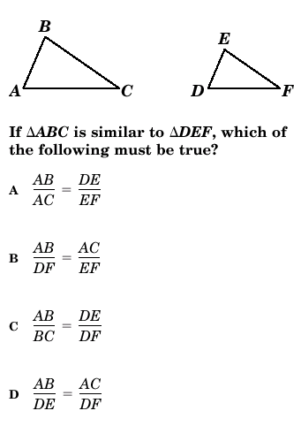

9.

10.
Are these triangles similar by the AA~ Postulate? Answer yes or no. If the triangles are similar, write a similarity statement.

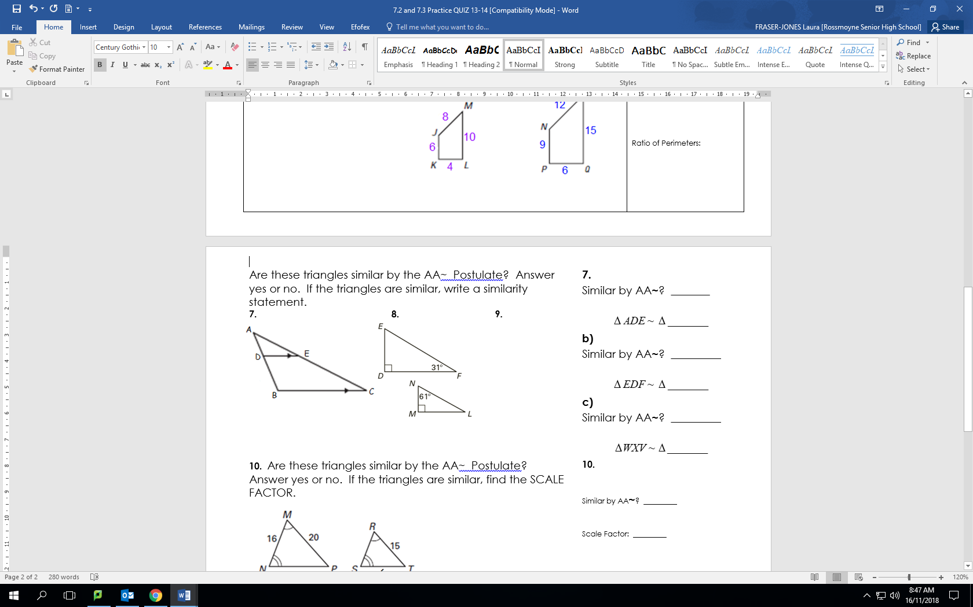

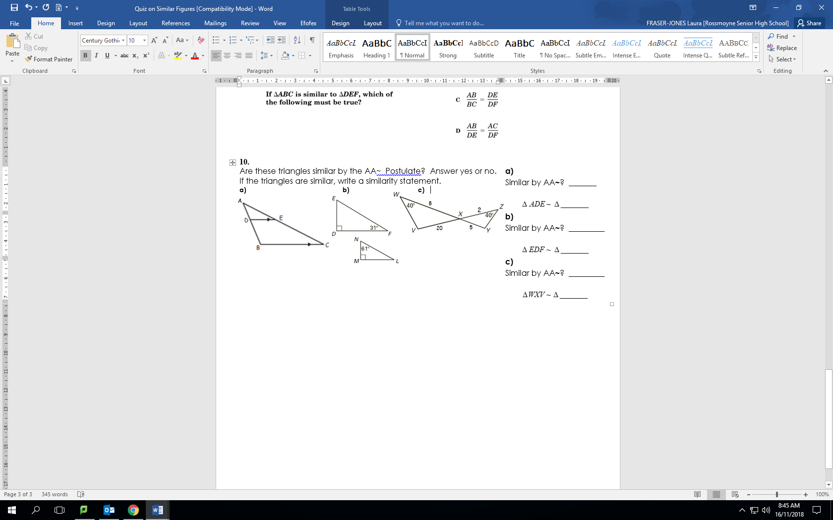
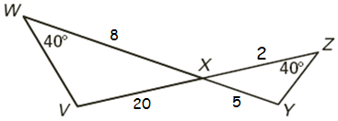
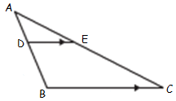
a) b) c)

11.
The angle of the roof on Kaya’s dollhouse is 56°. She built a scale model of the dollhouse with a scale ratio of 1 : 4. What is the measure of the angle of the roof of the model?

a) 14° b) 34° c) 56° d) 224°

12.
A tree with a height of 4m casts a shadow 15 m long on the ground. How high is another tree that casts a shadow which is 20 m long? (draw a diagram and solve)

